Technical Datasheet Input / Output Modules with Modbus RTU Protocol with Ethernet Interface
The I/O module communicates via an Ethernet interface and is designed to interface seamlessly with Modbus TCP/IP-compatible devices. It functions as an input/output device bridging the Modbus TCP/IP network and connected field devices.
The digital I/O module is sturdy, low-power, and easy to use. It is DIN-rail mountable and features LED indicators for module status and individual I/O ports.
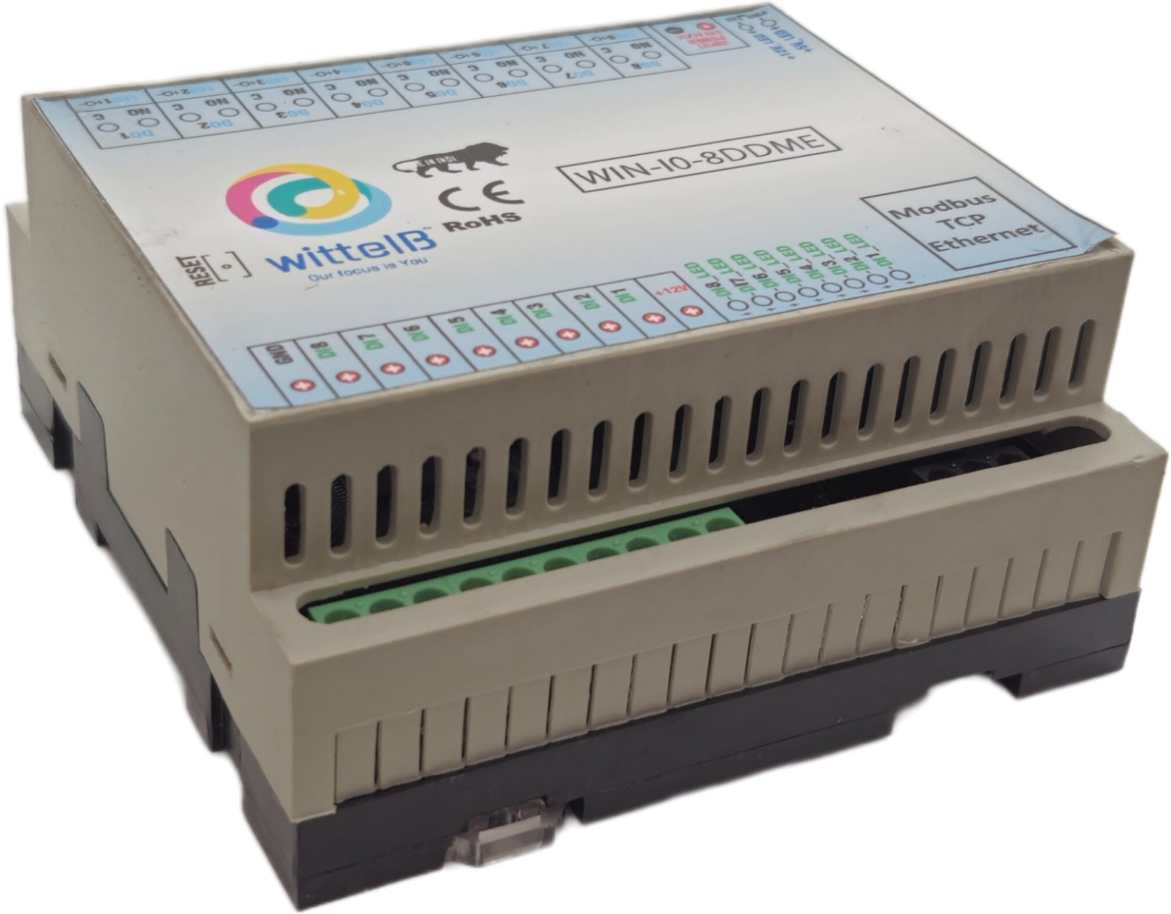
8 Port DI and 8 Port DO Module with Modbus TCP Ethernet: -

The IO modules enclosures are DIN rail Mountable. It’s a closed Enclosure with openings for connectors and LED indicators.
The design of the modules incorporates ‘resettable Fuses’ to safeguard against reverse polarity connection both for Power and Communication port. LED indicators for each of the IO ports as well as for the module Power.
The board also has ‘reverse polarity’ protection both for input Power connector. The communication port also has signal isolation and additional Jumper for end of line’ 120 ohms termination resistance which may or may not be used.
Specifications
General –

I/O Connectors 2 Pin 5.08 mm screw Terminal Blocks with max 2.5 sq mm cable size.
Dimensions 110 mm B x 110 mm L x 50 mm H
Input Power 12 – 24 VDC or 24 V AC/DC
Power Consumption 12V DC @ 500 mA
Operating Temperature 0 – 60° C (32 ~ 140°F)
Storage Temperature -20 - 70° C (-4 ~ 158°F)
Storage Humidity 5 ~ 95 % RH, non –Condensing
Certifications  

Digital Output (DO) –

Channels 8
Contact Form 1A (SPST)/ 1C (SPDT)
Contact Material Ag Alloy
Contact Capacity 10A @ 240VAC, 10A @ 28VDC
Coil Voltage 5 – 48 VDC
Coil Power 0.36 W
Insulation Resistance 250MΩ
Electrical Life 1 x 10^5
Mechanical Life 1 x 10^7
Operating Time 7 msec, Max 15 msec
Release Time 2 msec, Max 6 msec

DI Inputs –

Channels 8
Sense Voltage 3.3 – 30 VDC
Sense Logic Logic ‘0’ = <1 VDC, Logic ‘1’ = >3.3 VDC
Isolation Optically isolated
Response Time 2 msec, Max 6 msec

Additional Features: -
All inputs and communication ports isolated
Input power reverse polarity safety
ESD Safety IEC 61000-4-2, ± 30KV contact, ± 30KV air
EFT IEC 61000-4-4, 50A (5/50ms)
750V isolation.
CRC Error check.
No configuration needed on the IO board

Configuration Settings -
1. Communication Speed 10/100 Base-T Ethernet compatible interface
2. Slave ID Configurable via web interface
3. Function Codes for DO 0x05: Write Single Coil.
Default (0x01, Read Coils).
4. DO Register Address 0,1,2,3,4,5,6,7.
5. Function Code for DI 0x01, Read Coils
6. DI Register Address 8,9,10,11,12,13,14,15
7. Function Code for Pulse Counter 0x03, Holding Address
8. Pulse counter address 0,1,2,3,4,5,6,7.

Recommended Cable Electrical Characteristics: -
22 AWG Cable Shielded and twisted pair
Tinned Copper Recommended
Nominal Conductor DCR 14.7 ohm / 1000 ft
Nominal Capacitance 11 pf / feet (conductor to conductor)
High Frequency Non-Insertion Loss 0.5db / 100ft

Note: -
For MODBUS communications, a shielded and twisted pair cable is used. One example of such cable is Belden 3105A

K-Factor Description:
The K-Factor defines the scaling ratio between the raw pulse count and the engineering unit value The incoming pulse count from the sensor is divided by the K-Factor to obtain the displayed or transmitted value.
When a K-Factor is configured, the device automatically calculates:
$$\text{Displayed Value}=\frac{\text{Pulse Count}}{\text{K-Factor}}$$
The resulting scaled value is then made available through the Modbus register for monitoring or data acquisition.
Example:
If the pulse counter registers 10,000 pulses and the K-Factor is set to 100,
$$\text{Displayed Value}=10,000/100=100$$

Notes:
- The K-Factor should be set according to the sensor’s calibration constant or system scaling requirements.
- Changing the K-Factor affects only the displayed and Modbus values, not the actual pulse counting process.

Configuration Guide – Ethernet Modbus TCP/IP IO Module:-
1. Open a web browser (Google Chrome, Microsoft Edge, Firefox, etc.).
2. In the browser’s address bar, type the default IP address:
192.168.0.160
3. Press Enter. A message will appear saying:
“Please go to http://192.168.0.160/setup.”
4. Copy this link (http://192.168.0.160/setup) and paste it into a new browser tab.
5. Press Enter again to open the Setup / Configuration Page of the device.
To Reset the Device to Default Settings
· Place the jumper on the designated Reset position on the device.
· Press the Reset button once.
· The module will reboot and revert to its default IP address: 192.168.0.160.
To Change the IP Address
· On the Setup / Configuration Page, enter the new IP address you wish to assign.
· Click Submit to save the new settings.
· The device will automatically apply the new IP address.
Note:
· Ensure your PC’s IP address is in the same network range (for example, 192.168.0.xxx) when accessing the module.
· After changing the IP, you must use the new address to log in again.

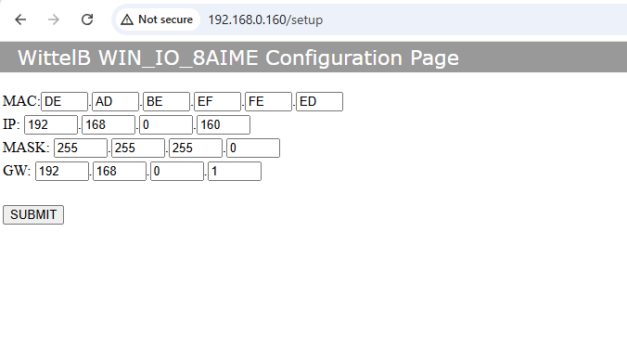
8 DDME

DI
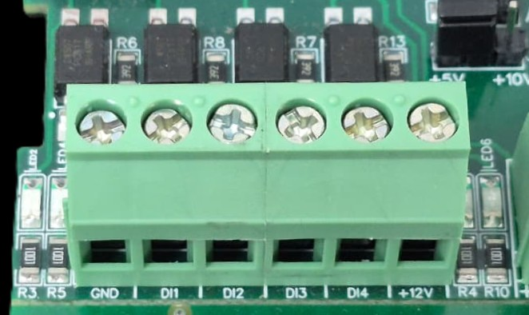
I/p device
I/p device
I/p device
I/p device

- Operation: The module provides four isolated input channels (DI1–DI4) for sensing external signals or dry contacts. These inputs are opto-isolated for circuit protection.
- Terminal Layout:
  - GND: Common Ground reference.
  - DI1 – DI4: Individual Digital Input channels.
  - +12V: Internal reference voltage for sourcing "Dry Contact" switches.
- Wiring Options:
  - Dry Contact: Connect a switch between the +12V terminal and any DI pin.
  - External Voltage: Connect the external signal to a DI pin and the external ground to the GND terminal.
- Voltage Rating: The input circuitry is rated for a maximum of 80VDC. Ensure external signals do not exceed this limit to prevent damage to the isolation ICs.

DO

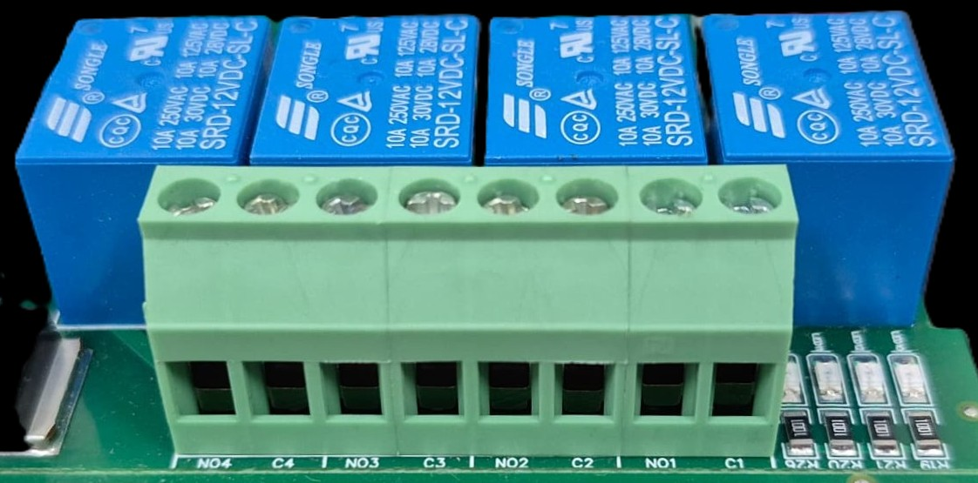




L
O
A
D
N

P
L
O
A
D
N

P
L
O
A
D
N

P
L
O
A
D
N

P

- Digital Output (DO) operation: Each channel provides two terminals: C (Common) and NO (Normally Open). When the relay coil is energized, terminal C is internally connected to NO, allowing current to flow. When the relay is de-energized, the connection between C and NO remains open, and the load stays OFF.
- Load Wiring Connections:
  - AC Load Connection: The AC Live (Phase) wire should be connected to terminal C. The load is connected between terminal NO and Neutral (N).
  - DC Load Connection: The positive supply (+V) should be connected to terminal C. The load is connected between terminal NO and Ground (GND).
- Crucial Safety Recommendation and Rating: It is strongly recommended to switch the Live (Phase) conductor in AC applications to ensure the load is safely de-energized when the relay is off.
Note: Ensure that the connected load does not exceed the relay’s contact rating of 10A @ 250VAC (or 10A @ 125VAC) or 10A @ 30VDC (or 10A @ 28VDC).

DO 1 DO 2 DO 3 DO 4 DO 5 DO 6 DO 7 DO8
I/P Power 24 V DC
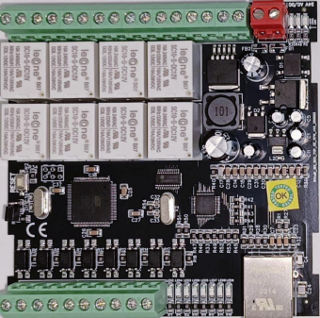

Default IP Reset Jumper

Modbus TCP Ethernet

GND DI8 DI7 DI6 DI5 DI4 DI3 DI2 DI1 +12v

Note –: Configuration Guide is separately provided for the configuration of the module.

Contact us: -
Augmatic Technologies Pvt. Ltd,
Plot no 6, Shah Industrial Estate II,
Kotambi,
Vadodara – 391510.
Email – Sales@wittelb.com
Support: support@wittelb.raiseaticket.com / +91 94038 92805

